**First created** **Gradle project**

**In this project there I used 2 classes**

**One is for variables and name of that class is lcVariables.java.**

**Second is for functions name of that class is tradeFinanceFunctions.java.**

After writing code for both classes compilation takes

**Compilation was done in terminal :**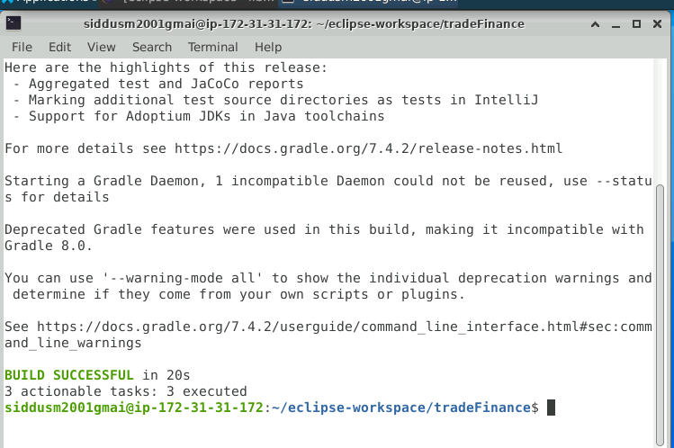

**In eclipse folder name of jar file was changed to tradeFinane-1.0.**

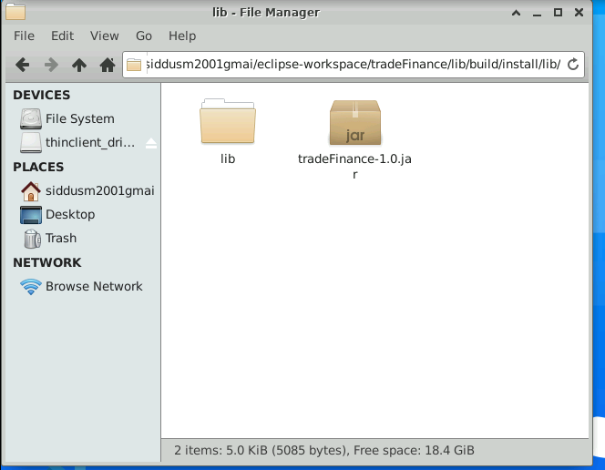

**Started the test network with help of command line :**

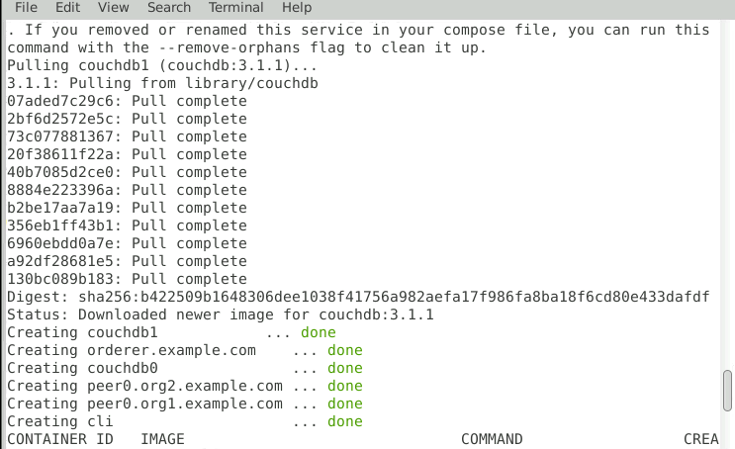

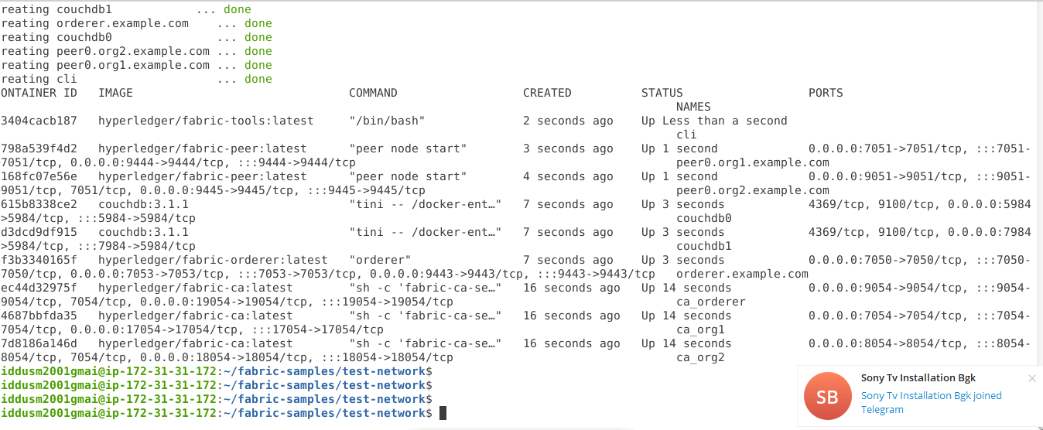

**created a communication channel for the peers in the test network**.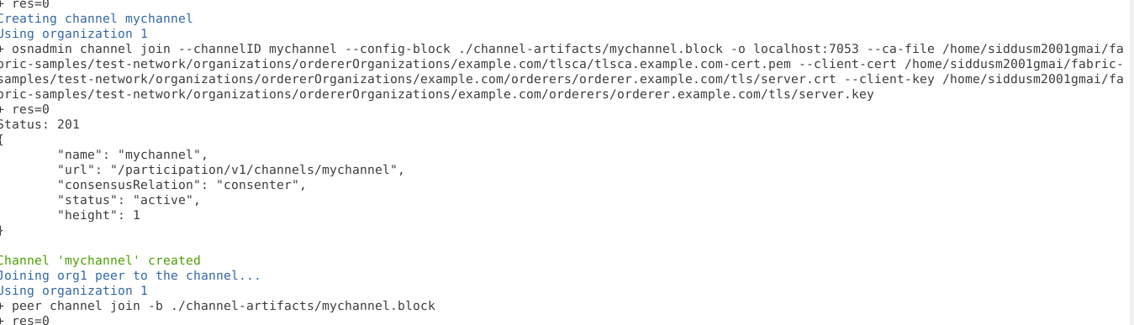

**listed the newly created tradeFinance.tar.gz package.**

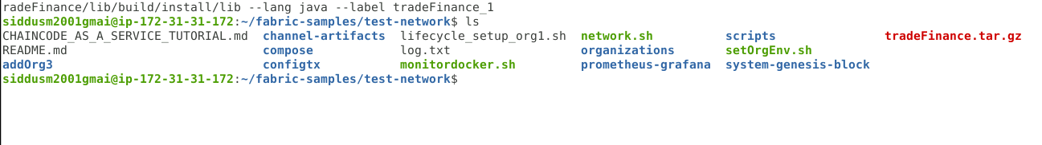

**Installation of chain code was done on both organizations:**

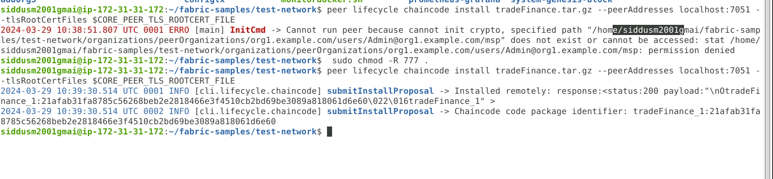



**Approval of chain code done after that checking commit readiness and committing chain code to myChannel was done :**

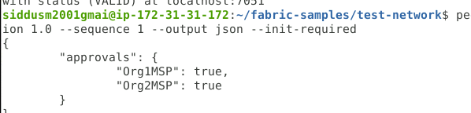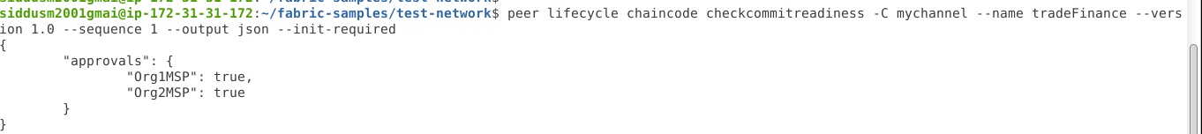

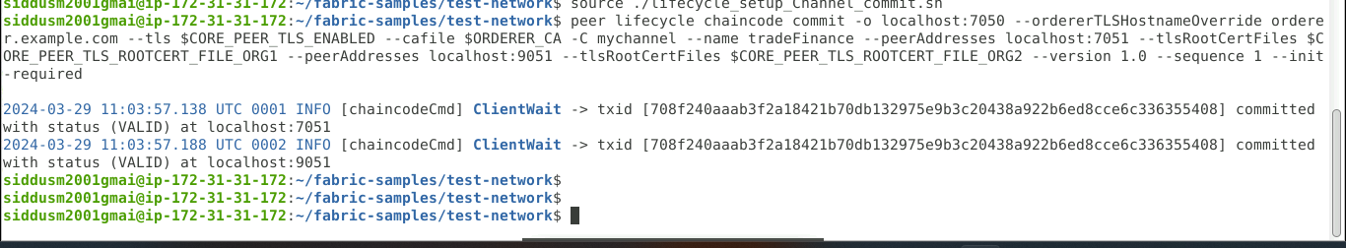

**In the final functions invoked successfully.**

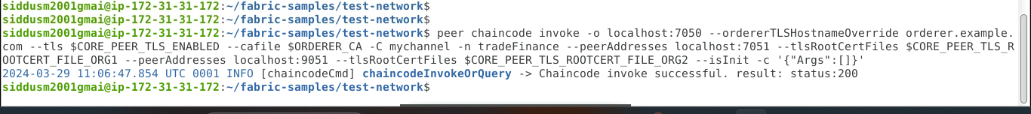

**1.requestLetterOfCredit:**

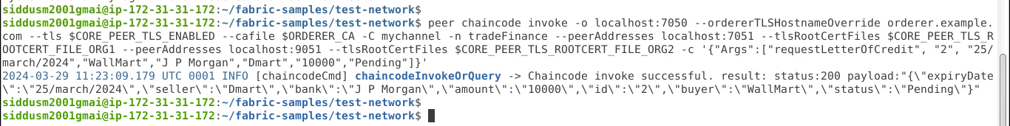

**2.issueLc:**



**3.AcceptLc:**



**4.ViewLc:**

